

**COURSE PLAN**

**as part of the**

**Training & Supervision Agreement**

**(TSA)**

for PhD candidates of the

Utrecht University Graduate School of Life Sciences

Version May 2019

Dear PhD candidate,

Welcome to the Utrecht University Graduate School of Life Sciences (GS-LS). The GS-LS unites 14 thematic [PhD programmes](https://www.uu.nl/en/education/graduate-school-of-life-sciences/phd-programmes/future-phd-candidates) that offer training in specific areas of Life Sciences research. As a PhD candidate you are required to register in the university-wide PhD candidate tracking system [MyPhD](https://myphd.uu.nl/registratie/) before a PhD track can start. Throughout the track, supplements can be entered into this system. Near the end of the PhD track, the first supervisor is required to register further steps in MyPhD for the progress and completion of the track and the PhD Ceremony.

**Supervision**

During your PhD track, you will be supervised by one or more **supervisors** (*promotores*: full professors, the primary supervisor being affiliated with Utrecht University or UMC Utrecht) and one or more **daily supervisors** (*copromotores*: associate or assistant full professors of Utrecht University, UMC Utrecht or other knowledge institutions). In addition, a **Supervisory Committee** (*aio-begeleidingscommissie*) must be appointed, consisting of 1-2 scientists who are not involved in your project.

All these parts of your supervision are entered in [MyPhD](https://myphd.uu.nl/registratie/).

**Training & Skills**

At the start of your PhD track, it may not be entirely clear yet which training, workshops, courses, seminars, symposia etc. you will attend during your PhD track. Still, it is important for you that you discuss the knowledge and skills you will need to acquire in the course of your PhD track with your supervisor(s) right from the beginning. You will discuss this ‘course plan’ and your progress on the development of different competences during the annual meetings with your supervisor and with your Supervisory Committee.

**You may use this document to set up your (draft) course plan. Please use this in consultation with your supervisor and your programme coordinator. This course plan could be changed during the PhD track.**

**Your training programme**

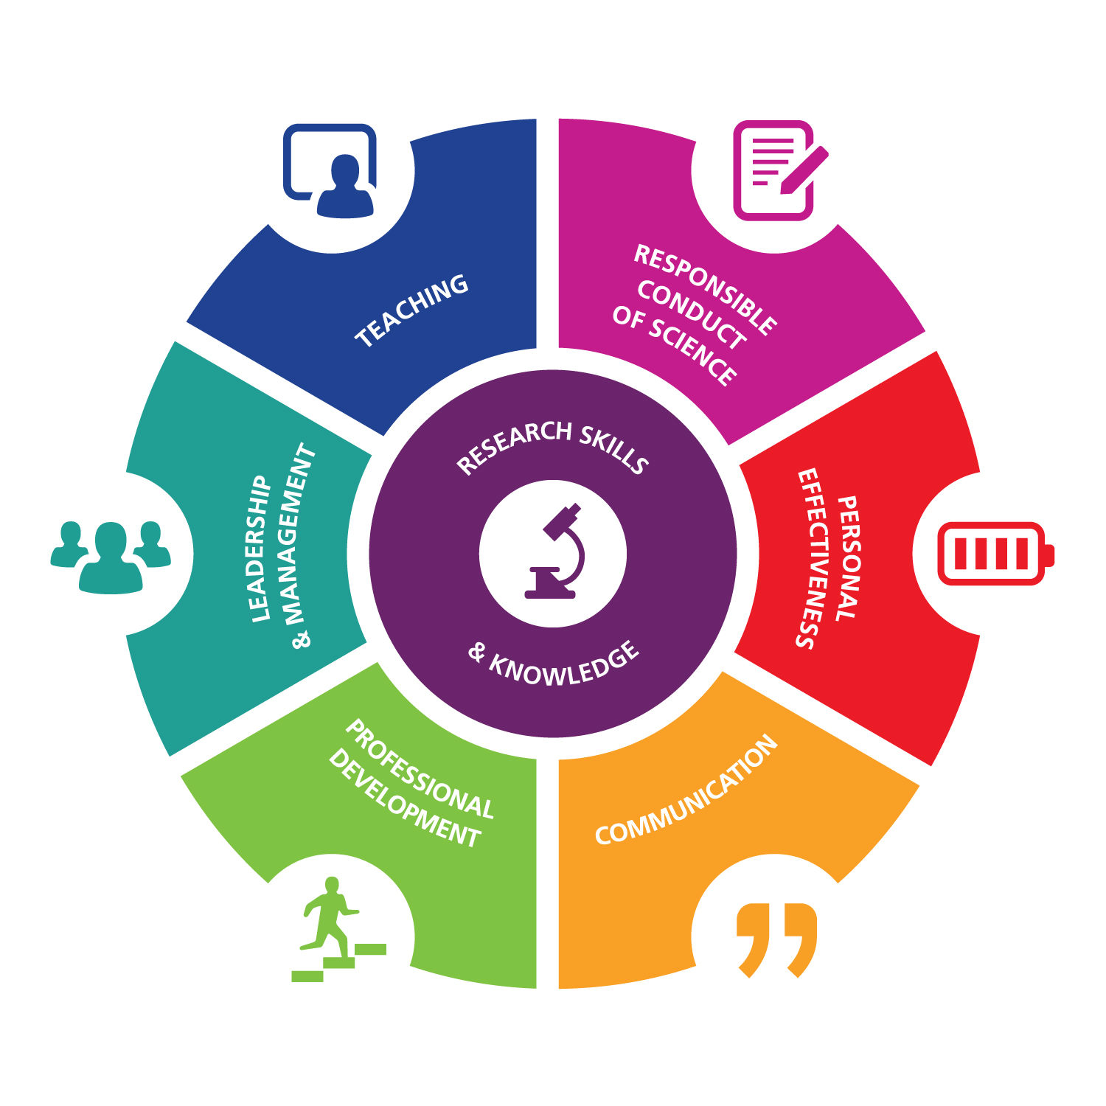

It is important to develop your competences as a researcher and as an individual. Meaningful competences to develop are; *Research Skills & Knowledge*, *Responsible Conduct of Science*, *Personal Effectiveness*, *Professional Development*, *Leadership & Management*, *Communication* and *Teaching*. These competences lead to further development for an academic future as well as for a future outside academia. The total training programme may constitute of a mixture of courses, seminars, journal clubs, PhD retreats, symposia, etc.

Disciplinary or thematic courses will be offered by the PhD programmes. Other courses and workshops (e.g. general courses) may be followed within the [PhD Course Centre](http://www.bit.ly/PhDCourseCentre). Of course, you may also attend other courses that are useful to you.

**Content of the programme**

The proposed programme should be constituted as follows:

* Training and education should comprise a minimum of 5 credits**[1]** for each year of research appointment, which will be at least 2 years and no more than 4 years (10-20 credits in total).
* A **minimum of 40%** of the total credits should be spent on **disciplinary or thematic courses of the PhD programme** to which the PhD candidate has been admitted.
* Courses offered by other PhD programmes of the GS-LS may be attended free of charge, if space permits (contact the programme coordinator in advance).
* A **minimum of 20%** of the total credits should be spent on **general courses**.
* A **maximum of 20%** of the total credits may be spent on symposia/conferences.

You should keep track of the progression and adjustment of your training programme by collecting and saving the certificates of attendance that are provided by each course in a PhD Training Portfolio. You will need this information for the annual progress reports. Moreover, at the end of the PhD track, your programme coordinator will need them to be able to assess whether you qualify for the PhD Training Certificate of the GS-LS.

**Training Certificate of the GS-LS**

At the end of the PhD track the director/coordinator of the PhD programme evaluates your qualification for the Training Certificate on behalf of the Board of Studies of the GS-LS. The procedure for application of the Training Certificate and the application form can be found on the [website of the GS-LS](https://www.uu.nl/en/education/graduate-school-of-life-sciences/phd/finishing-your-phd). Please request your Training Certificate **at least four weeks** before your defence.

**PROPOSED TRAINING PROGRAMME**

**Name PhD candidate:**

**PhD programme1:**

|  |  |  |
| --- | --- | --- |
| *Rows may be added if necessary* |  |  |
| **Courses and training offered by the PhD programme**  **(min. 40% of total)** | **Organising Institute** | **European**  **Credits** |
|  |  |  |
|  |  |  |
|  |  |  |
|  |  |  |
|  |  |  |
|  |  |  |
|  |  |  |
|  |  |  |
|  |  |  |
|  |  |  |
|  |  |  |
|  |  |  |
| **General courses and training (min. 20% of total)  (e.g. from the PhD Course Centre)** |  |  |
|  |  |  |
|  |  |  |
|  |  |  |
|  |  |  |
|  |  |  |
|  |  |  |
|  |  |  |
|  |  |  |
|  |  |  |
|  |  |  |
| **Other disciplinary/thematic or general training** |  |  |
|  |  |  |
|  |  |  |
|  |  |  |
|  |  |  |
| **TOTAL** |  |  |

**Signatures**

Name Signature Date

PhD candidate:

(Daily) Supervisor:

Coordinator of the   
PhD programme[2]:

1. according to the European Credit Transfer System (ECTS) 1 credit = 28 hr and 1.5 credit = 1 week
2. PhD programmes of the Graduate School of Life Sciences are: Biomembranes, Cancer Stem Cells and Developmental Biology, Cardiovascular Research, Clinical and Experimental Neuroscience, Clinical and Translational Oncology, Computational Life Sciences, Drug Innovation, Environmental Biology, Epidemiology, Infection and Immunity, Medical Imaging, Molecular Life Sciences, Regenerative Medicine, Toxicology and Environmental Health.

   In case the PhD candidate is not part of one of these PhD programmes, the programme coordinator’s signature is not applicable.